Intro
You’re anxiously watching the progress bar on your monthly AI budget as your coding agent retries the same command-line action for the fifth time. "This time it'll work," you tell yourself.
A little while later, you're scratching your head as the agent you tasked with adding a simple new endpoint has produced a two-page design document detailing 15 steps. You let out a sigh and start coding it yourself.
If you’ve been using AI coding agents or assistants in the past six months, any of this should sound familiar. You've either made peace with it or — like me — been desperately trying to stretch that precious token budget. In this post I’ll share some insights, practical tips, and a few handy tools that'll help your coding buddy go a little further.

Typical issues and tips to fix them
Contrary to what you might expect, the biggest savings are achievable through simple configuration. Tweaking your local setup to set some quality standards and guardrails will save you a surprising number of tokens. Let's run through the most important ones.
Use your AGENT.md to spawn subagents on the right model. By default, agents inherit the parent model — so if you’re running on Opus or GPT-5.5, every subagent token racks up at premium rates, even for trivial tasks like batch-reading a large codebase or knocking out a simple implementation. Specifying model selection criteria in your config is the single easiest win when using multi-agent workflows.

Model selection
- **File reading / code exploration subagents**: use `claude-haiku-4-5-20251001`or newer (Haiku). Fast and cheap for navigation tasks.
- **Implementation / reasoning subagents**: inherit session model (Sonnet or above).
- When in doubt, ask user!

The second biggest token sink for me were runaway loops — agents spending ten or twenty iterations hammering a command-line call that's missing permissions or just not producing the right result.
The fix is surprisingly simple: add a few lines to your global CLAUDE.md (or equivalent) config file.
For example:
- Be concise and goal-directed.
- Ask at most one clarifying question.
- Never repeat the same failed action more than twice.
- After 3 unsuccessful attempts, stop and report the blocker.
- Prefer the simplest solution and the fewest tool calls.
- Stop immediately when the task is complete.

My third area of savings was using dedicated tools to reduce both input and output tokens. Input tokens are typically three times cheaper than output, but they still add up fast in larger codebases where agents do a lot of reading and searching. I’ve tried a few tools for this; my current favorite is Graphify, which significantly sped up code searches in a Java Spring Boot project I was working on.
Graphify is an open-source skill that helps AI coding assistants understand multi-modal codebases by building a queryable knowledge graph from code, docs, papers and diagrams.

Tools

Caveman
Caveman is a tool that promises to cut output tokens by forcing the model to give shorter, less chatty responses.
After some testing, the promised savings seem exaggerated.
On simple Q&A flows the savings were negligible, as the table below shows. [ TODO: Fill in the actual token counts in the table ]

Configuration | Model | Input | Output
Standard | Sonnet | [ TODO ] | [ TODO ]
Caveman default | Sonnet | [ TODO ] | [ TODO ]
Caveman Ultra | Sonnet | [ TODO ] | [ TODO ]

Graphify
To test it properly, I ran a head-to-head comparison on the same Spring Boot codebase: Graphify vs. traditional grep + file read, using three behavioral code questions.

The results were clear. Graphify finished in 80.9s vs 163.4s for traditional search — roughly 2× faster — while consuming ~66k input tokens compared to ~225k. That's a 3.4× reduction in input tokens and ~2.8× lower cost. The images below show the full breakdown.
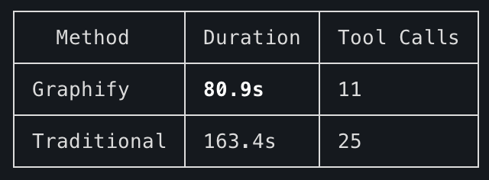
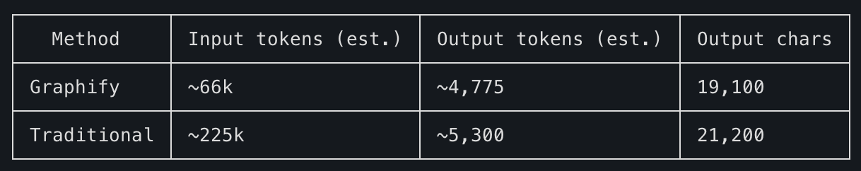
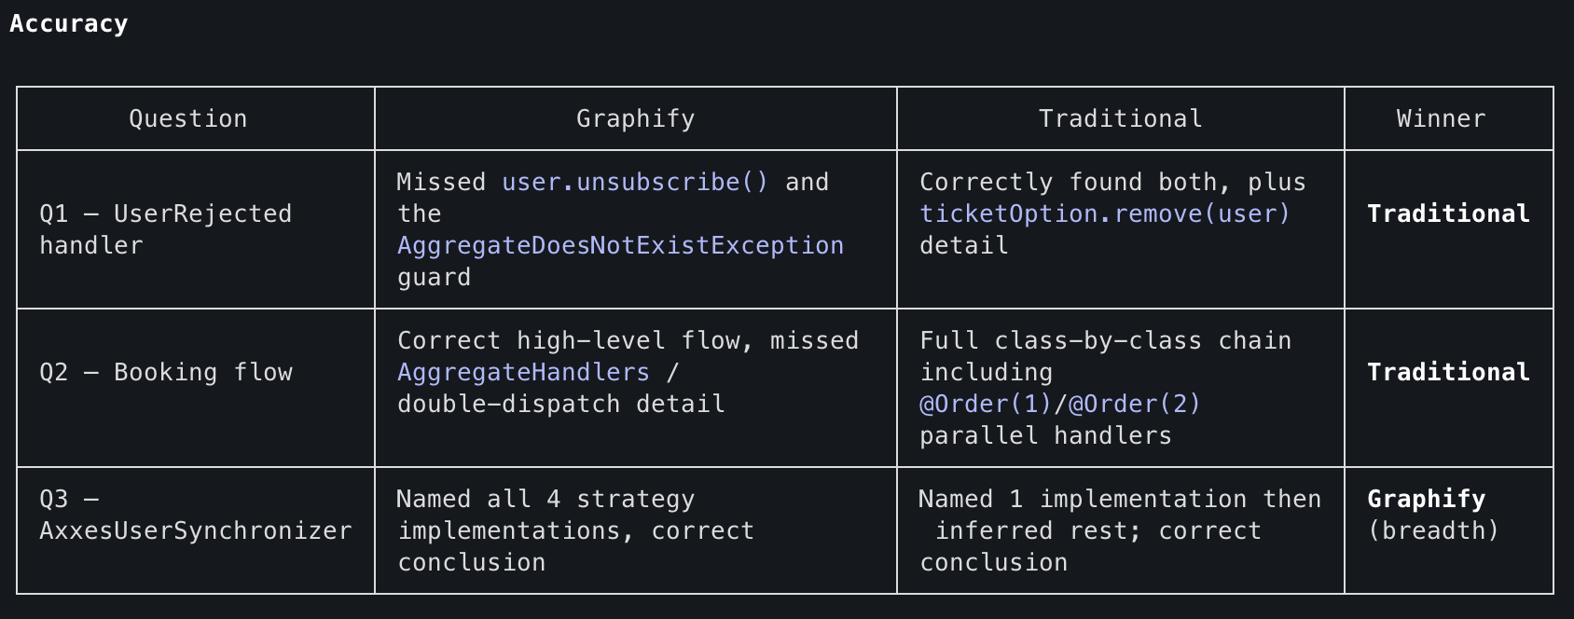
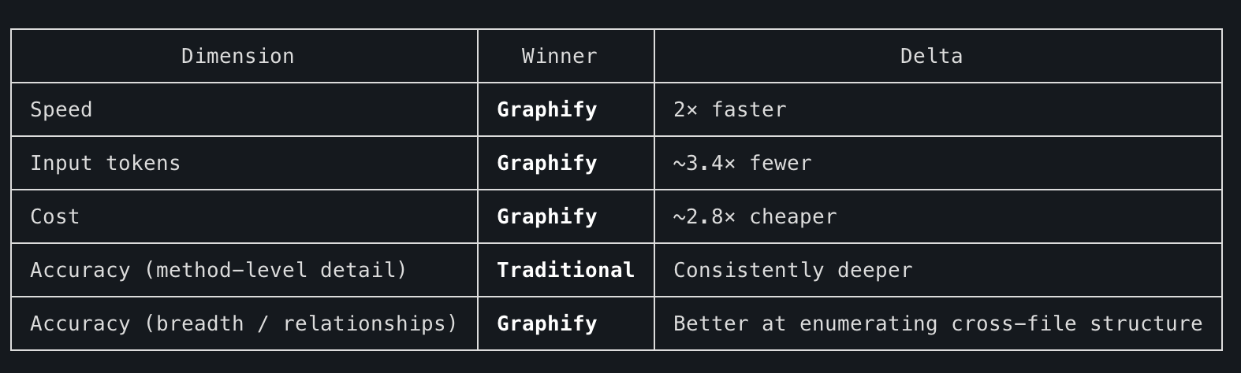
**Verdict:** Graphify wins on efficiency — speed, cost, and token consumption — but loses on depth for method-level behavioral questions. It's the right tool for "what depends on what" and "which classes implement this interface." Traditional grep + read is still necessary when you need to know exactly what a method body does: Graphify's graph captures structure, not semantics. Best used together.

Three-way comparison: Graphify vs Semble vs Traditional
I then added Semble — a snippet-level semantic search tool — to the mix. Here's how all three compare on speed, cost, and accuracy:
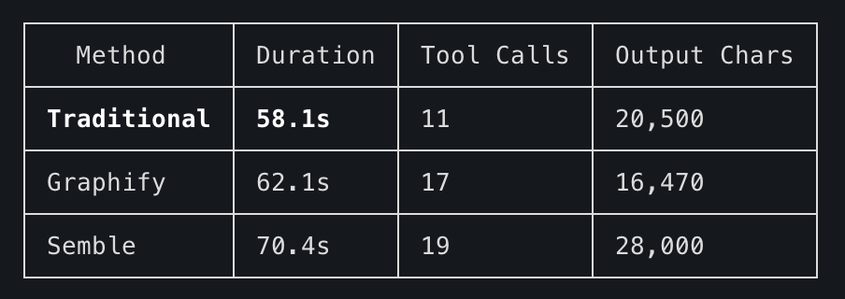
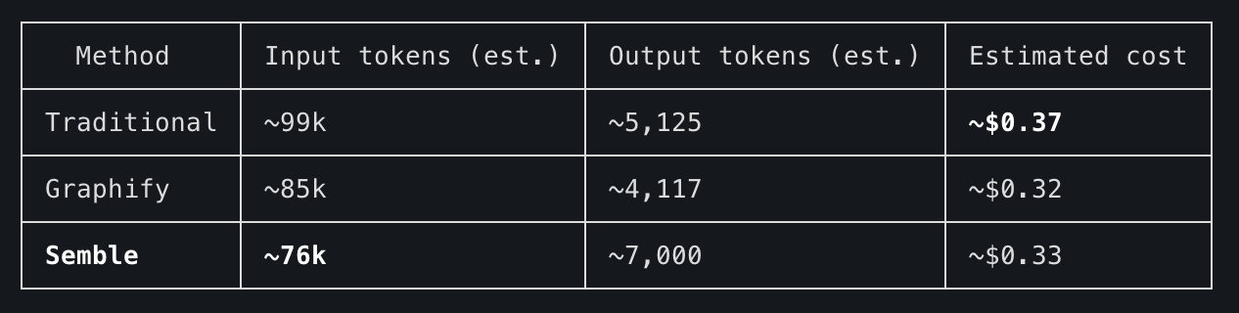
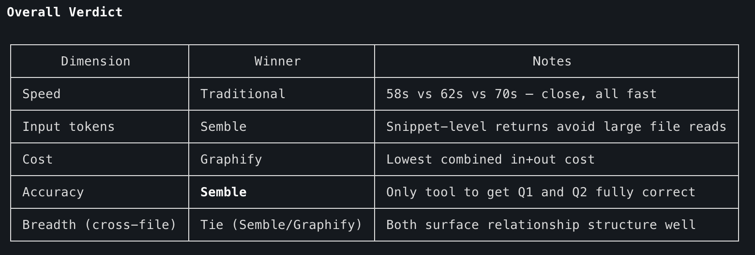
**Key finding:** Semble is the most accurate — it returns actual code snippets at the right line, giving the agent enough method-body detail to answer behavioral questions correctly while avoiding the full-file verbosity of traditional read. Graphify is fastest to navigate structurally but loses on behavioral accuracy. Traditional search is competitive on speed when you know where to look, but accuracy varies.

**Recommended workflow:** Semble for targeted behavioral questions → Graphify to map cross-file dependencies → Traditional read only when you need the full file context.

Ponytail
Ponytail enforces YAGNI ("You Aren't Gonna Need It") principles — nudging the agent toward the simplest possible solution and away from over-engineering.

For backend implementations this is a great fit — it consistently pushed the agent toward leaner, more straightforward solutions.

Frontend features are a different story, though.
When I asked both to implement a rating feature, Ponytail defaulted to a plain stepper while vanilla Claude built a custom 1–10 number picker. The custom component is more complex, but it also looks significantly better. For a feature the user will interact with constantly, that matters — the simpler output is functional but noticeably inferior. YAGNI has a UX cost on the frontend.

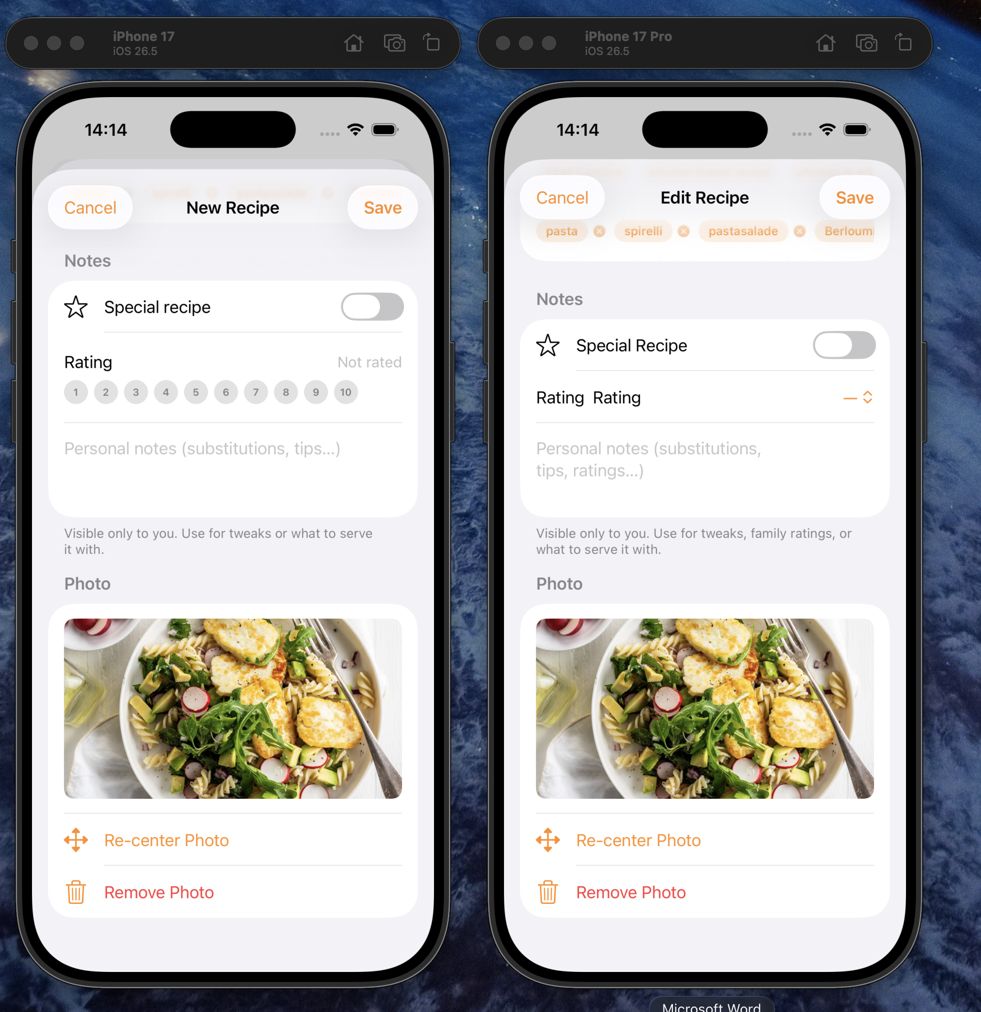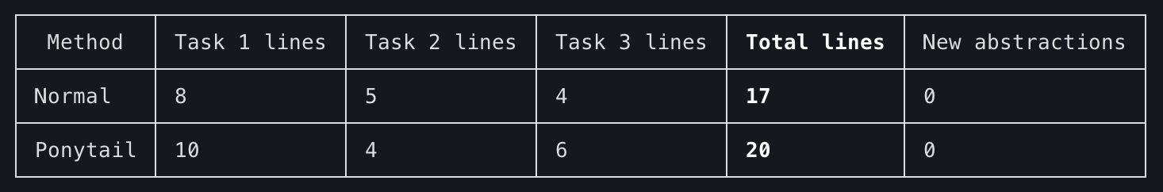
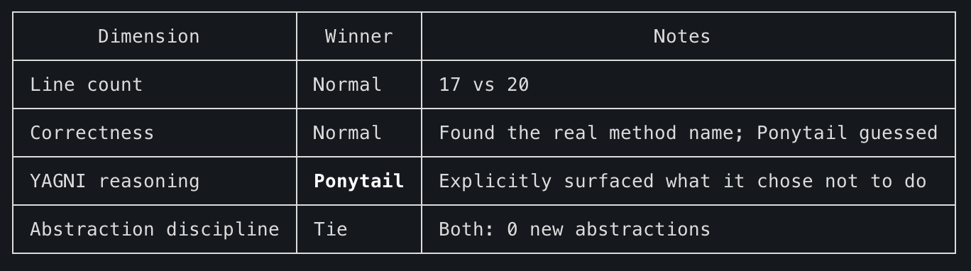

Open-ended implementation: the sync report task
To test Ponytail on a more open-ended backend task, I gave both agents the same prompt: add sync reporting to an existing user synchronization service. The difference in approach was stark.
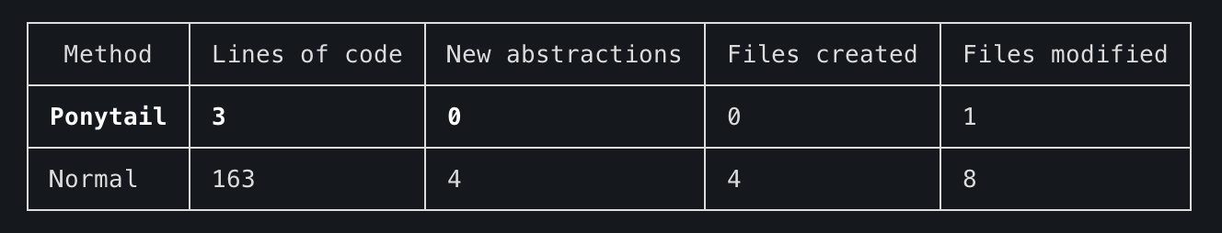
**What vanilla Claude built**

- ActionSyncStats record — return type for each action
- SyncStatus enum — SUCCESS/FAILURE
- SyncReport record — wraps timing, employee count, per-action stats
- SyncReportStore Spring component — volatile in-memory field
- Changed the `UserSynchronizationAction` interface return type — a breaking change across all 4 implementors
- New REST endpoint `GET /debug/users/_sync/report`
- New test cases

It's a coherent, well-reasoned system — but the interface change is the real cost. It touches 4 implementors and changes a public contract.

**What Ponytail built**

Three log lines: sync start, employee count fetched, sync complete with duration. It noted that per-operation logs already existed in the action classes, so `grep` already gives you counts — and that was enough.

**What Ponytail explicitly refused to build**

`SyncReport` record, `SyncReporter` interface, Actuator/Micrometer metrics, REST endpoint, email/Slack notifications, sync history persistence, and the interface return-type change. Its reasoning: "individual add/delete operations are already logged by the existing actions, so ops can grep counts."

The open-ended task summary says it all: Normal produced 163 lines of code across 4 new types and 8 modified files; Ponytail produced 3 lines in 1 file. That's a 54× difference in code output — and a corresponding difference in tokens spent generating it. Ponytail genuinely saves tokens on backend tasks. Just don't expect it to build the thing you didn't ask for, even when you probably should have.

